*Florida International University*

*School of Computing and Information Sciences*

Software Engineering Focus

Interactive Paint

User Story ID <303>

**Name:**

Daniel Mederos

**Team Member(s):**

Jim Louro

**Project:**

Interactive Paint

**Product Owner(s)**:

Francisco Ortega

**Mentor(s)**:

**Instructor**: Masoud Sadjadi

**User Story Name:** Test QT plugin on Visual Studio

* Description: **As a** User **I would like** to create a simple sample QT GUI **so that** I can run it cross platform on a computer or tablet for now.

Acceptance Criteria

* That Sample GUI should be able to run on a tablet and computer (Devices we currently own)

**Use Case** Run Sample GUI from Visual Studio

|  |  |  |
| --- | --- | --- |
| #**344** Test QT plugin on Visual Studio | | |
| ***Description*** | When the user runs the code, the sample GUI must show on the screen and must be able to exit | |
| ***Actor*** | User of Interactive Paint | |
| ***Precondition*** | QT plugin must be installed in Visual Studio | |
| ***Flow of Events*** | **User** | **System** |
| **1.** | User clicks run on visual studio | The GUI then shows up in the middle of a screen |

**Use Case Diagram**

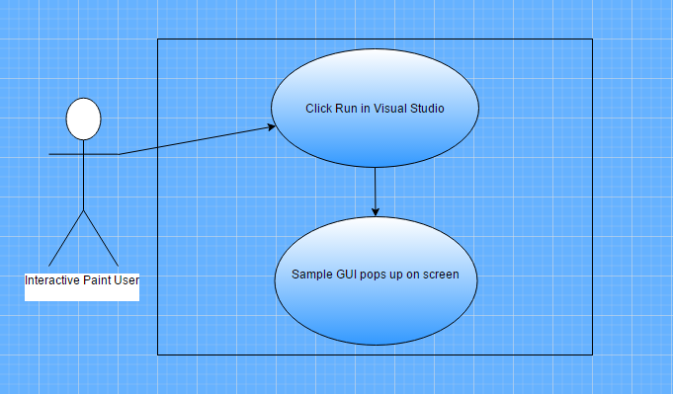

**Sequence Diagram**

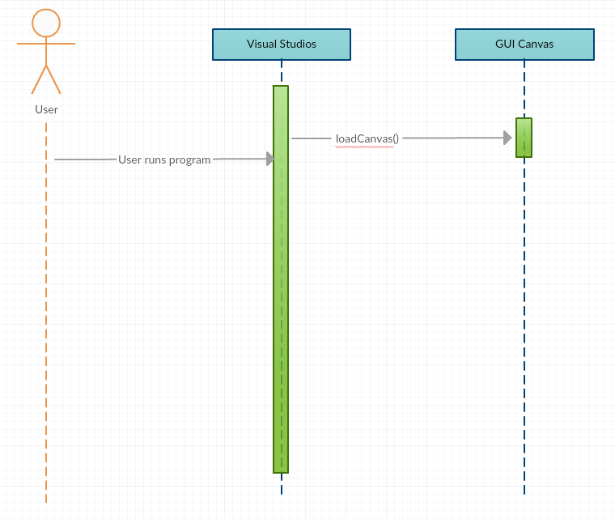

**Class Diagram**

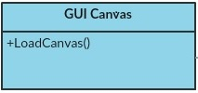

**Testing**

**Description:**

* Run the program so that the GUI pops up

**Work Log:**

**Unit Test**

**Test Case 1 (sunny)**

***Purpose:***to Test that GUI properly runs and pops up on the screen

* Precondition: The user must have QT plugin in order to run the GUI
* Input: User clicks the run in visual studio
* Expected Result: GUI pops up in the middle of the screen
* Actual Result: Actual result was found to be the expected result.
* Status: **PASSED**

